# Accessing The Sandbox

## Table of Contents

Steps To The Sandbox 3

Step 1 - Access Postman 3

Step 2 - Add Authorization Header 4

Step 3 - Identify API 4

Step 4 - Determine Test Scenario 5

Step 5 - Execute Test Scenario 6

Step 6 - Copy URL 6

Step 7 - Add URL 6

Step 8 - Execute Request 7

Challenge 7

## Steps To The Sandbox

#### Step 1 - Access Postman

[**https://www.postman.com/downloads/**](https://www.postman.com/downloads/)

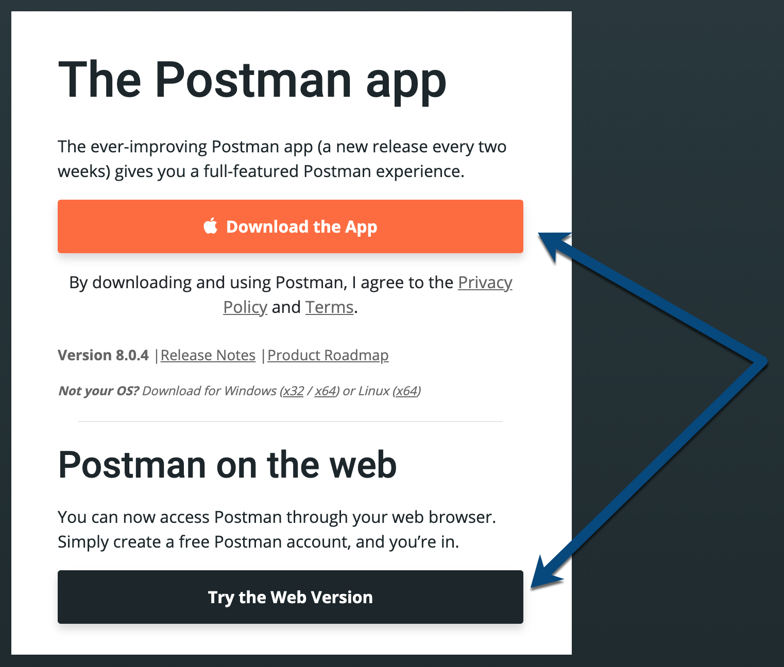

#### Step 2 - Add Authorization Header

#### **Authorization Value - Bearer viPC7H7nJ1vthf2cgfGWwgR/qsCnW3U0i1N2ICKjPFJyayqxXSmLPvdmyDhNh4BU**

#### Step 3 - Identify API

[**https://na.developers.tsys.com/home**](https://na.developers.tsys.com/home)

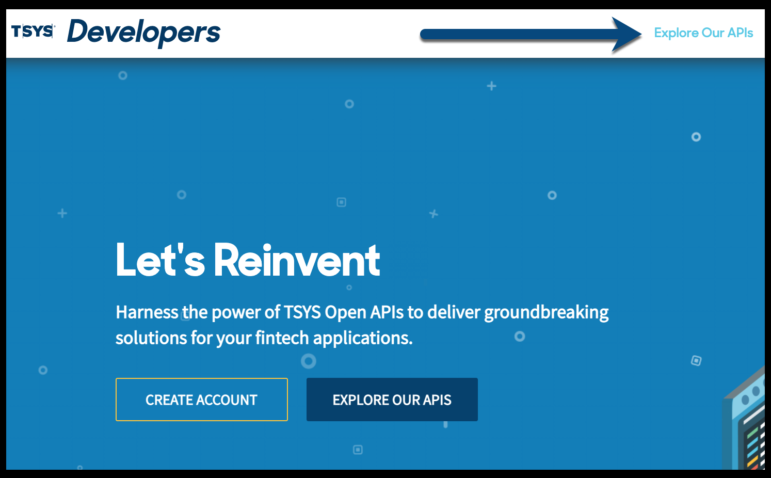

#### Step 4 - Determine Test Scenario

**For each API, we have multiple Test Scenarios available.**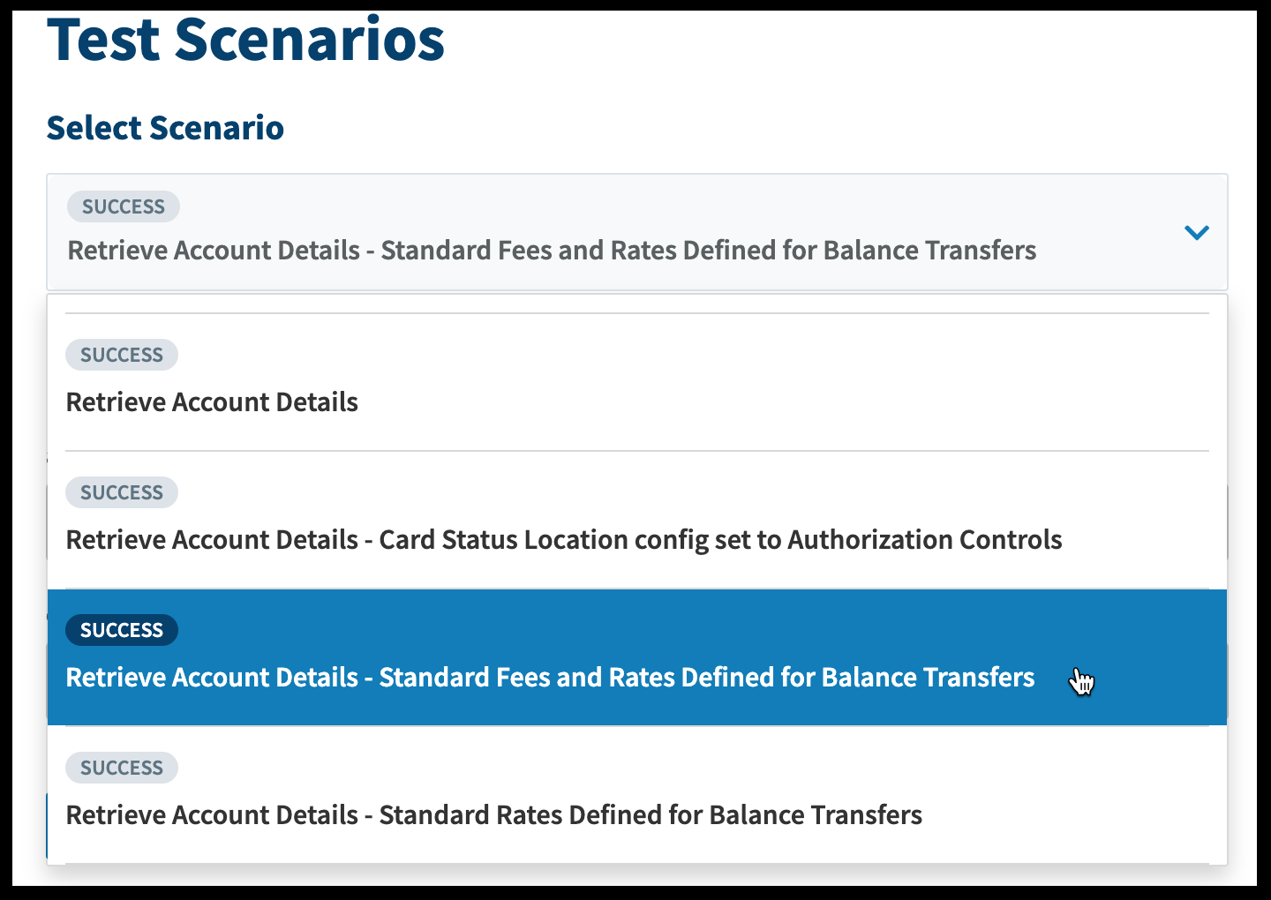

#### Step 5 - Execute Test Scenario

#### Step 6 - Copy URL

#### Step 7 - Add URL

#### 

#### Step 8 - Execute Request

